**ST2023**

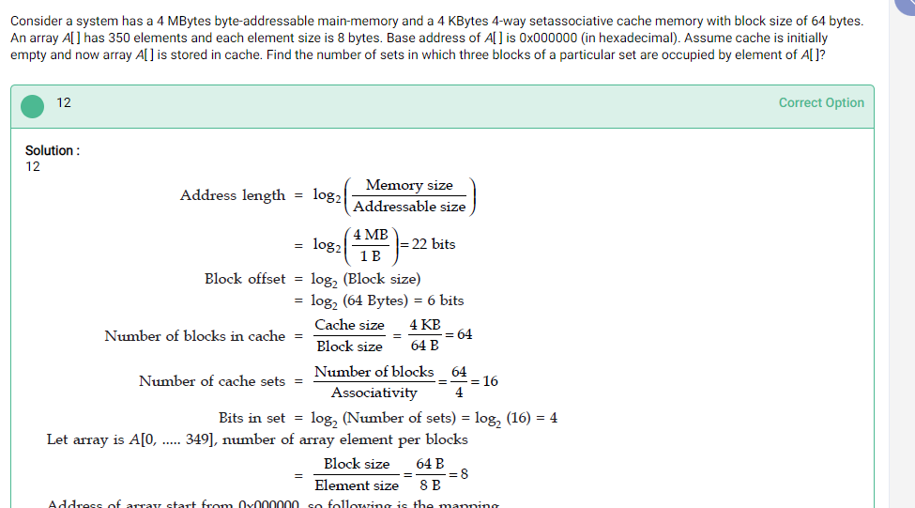29.

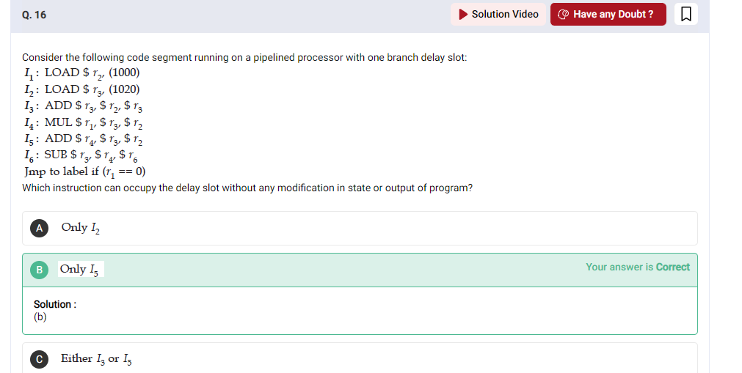

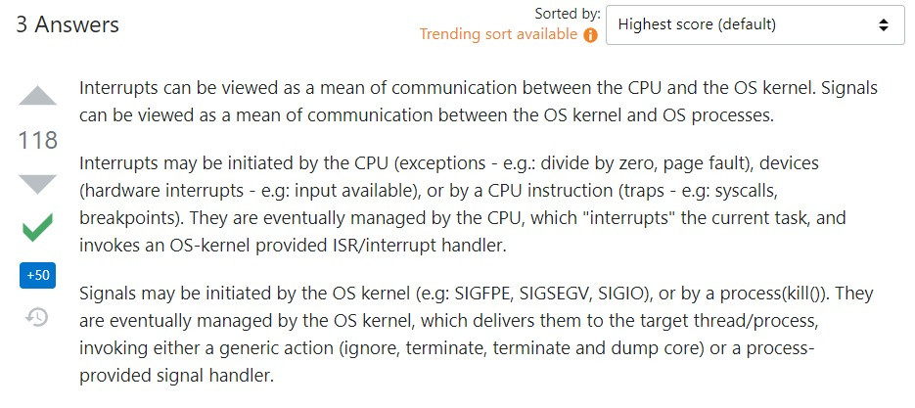

SEE:

https://docs.microsoft.com/en-us/windows/win32/fileio/synchronous-and-asynchronous-i-o?redirectedfrom=MSDN